Name:
Period:
Voltage & Salt Bridge Cells
Part 1: Salt Bridge Cells
- For the galvanic cell shown on the right, give the balanced half-reactions:
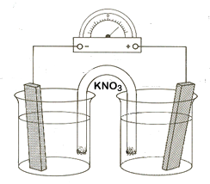
  - Oxidation:

  - Reduction:

- Write the overall reaction. (Make sure you add the half-reactions so that the electrons cancel out!)
Cu⁺ Cu
Ni Ni²⁺

- What is the overall electrochemical potential (voltage) for the cell shown on the right?

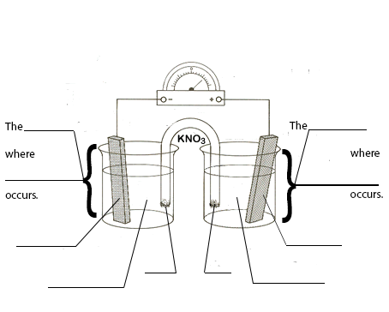
- Using the electrochemical reaction given, fill in the blanks on the diagram to the right with the appropriate letter from the choices below.
Mn(s) + 2 Ag⁺ Mn²⁺ + 2 Ag(s)
Follow the “ABC” pattern explained in class.
  - Oxidation
  - Reduction
  - Cathode
d
  - Anode
  - Mn (s)
  - Ag⁺ (aq)
  - Mn²⁺ (aq)
  - Ag (s)
  - K⁺ into solution
  - NO₃⁻ into solution

- What is the overall cell potential (voltage) for this galvanic reaction?

Part 2: Half reactions and voltage:
For the following reactions:
- Divide the overall reaction given into half-reactions
- Determine which is reduction (charge is reduced, electrons are gained).
- Determine which is oxidation (charge is increased, electrons are lost).
- Balance each half-reaction. (Add the appropriate coefficients to balance atoms, then balance charge by adding an appropriate number of electrons where needed.)
- Find the voltage for each half-reaction as written. (This means changing the sign for the half-reaction written opposite from on your table of Standard Reduction Potentials.)
- Calculate the overall cell voltage.
- Determine whether or not the reaction is spontaneous. (Will it act as a galvanic cell?)

- Zn(s) + Fe²⁺ -----> Zn²⁺ + Fe(s) | Eº (Voltage)
Reduction half-reaction:

Oxidation half-reaction:

Overall voltage:

Is this a spontaneous reaction? | Yes/No
- Br₂(l) + 2Fe²⁺ -----> 2Br⁻ + 2Fe³⁺ | Eº (Voltage)
Reduction half-reaction:

Oxidation half-reaction:

Overall voltage:

Is this a spontaneous reaction? | Yes/No
- Ni²⁺ + 2Cl⁻(aq) -----> Ni(s) + Cl₂(g) | Eº (Voltage)
Reduction half-reaction:

Oxidation half-reaction:

Overall voltage:

Is this a spontaneous reaction? | Yes/No
- H₂(g) + Cr³⁺ 2H⁺ + Cr²⁺ | Eº (Voltage)
Reduction half-reaction:

Oxidation half-reaction:

Overall voltage:

Is this a spontaneous reaction? | Yes/No
- 2 H₂O(l) + Pb²⁺ O₂(g) + 4H⁺ + Pb(s) | Eº (Voltage)
Reduction half-reaction:

Oxidation half-reaction:

Overall voltage:

Is this a spontaneous reaction? | Yes/No

